**Consistency Counts: How Daily Routines Support Child Development**

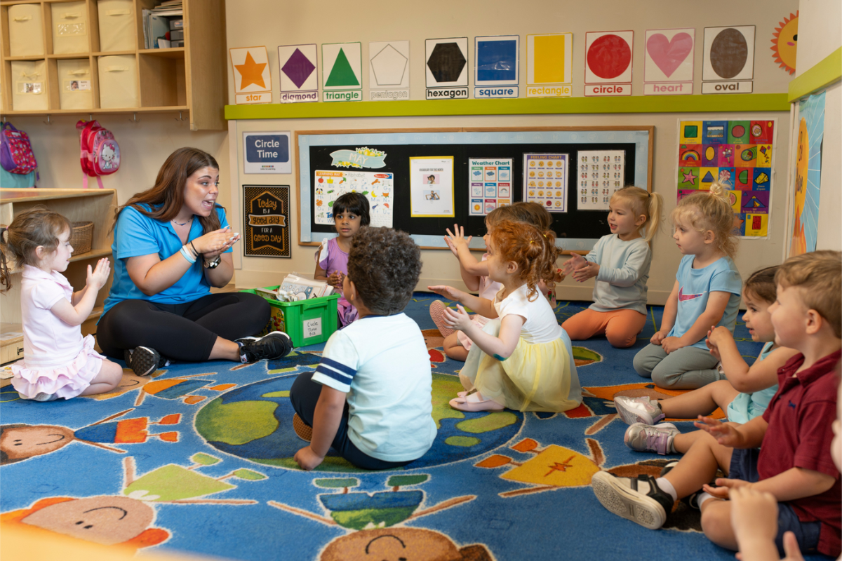

Can having established routines for your child impact their development? We’re speaking with Amber Fine, Director of Operations and Student Behavior, to find out. Amber joined our organization in 2022 and is a Licensed Mental Health Counselor. She’s worked with children of all ages and brings valuable insight into how routines can support healthy development.

**Hi Amber! Why is establishing and sticking to routines so important for young children?**

Daily schedules for children help them feel safe and confident. For infants, regular times for eating, sleeping, and playing send a message of care. Toddlers learn what to expect, which makes them feel secure and in a small way, “in charge.” Preschoolers use routines to build independence and practice self-control. When children know what’s coming next, it’s easier for them to handle changes and manage their feelings. This is where the importance of consistency comes in—by maintaining predictable routines, children feel more grounded and supported as they navigate their day.

Our school follows a consistent daily schedule, setting students up for success. They know when to expect meals, playtime, and rest, which offers comfort, helps with emotional regulation, and makes transitions smoother.

**What are some important routines families should establish?**

It’s helpful for families to create consistent routines for sleep, meals, playtime, and daily transitions. For example, a regular bedtime routine supports restful sleep and emotional security. Consistent meal times help children develop a healthy relationship with eating by creating predictable moments to satiate their hunger and connect with family.

**What about on weekends? Is it okay if routines are broken?**

Weekends can be more relaxed, but keeping some structure is helpful for children. Some examples may be sticking to consistent mealtimes and rest periods. Keeping key routines in place makes for an easier transition back into the weekday schedule.

**How should parents handle summer routines?**

Summertime can bring schedule changes, making sticking to routines more challenging. Keep in mind that loose routines can still provide structure. A schedule with consistent wake-up times, meals, and rest is beneficial. If your child is enrolled in preschool, keeping them enrolled during the summer months not only sets them up for success in the fall, but also provides a multitude of fun summer activities with friends. For school-age students, summer camps can provide exciting opportunities while still following a routine.

Summer at our school means fun, discovery, and adventure while still maintaining routines.

One day might feature a music show, another might include outdoor water play, but each day follows familiar routines like storytime, outdoor play, and meals.

**How do routines support social-emotional growth?**

Routines help young children develop independence by providing clear expectations and opportunities to complete tasks on their own. With regular practice, children gain confidence in their abilities. As an example, when a preschooler joins our school, they’ll see students clearing their plates after lunch and getting their own naptime items. At first, participating in this routine might be challenging, but by watching their peers and practicing daily, they’ll soon master these tasks and feel a sense of pride! Predictable routines also provide opportunities for children to feel a sense of control and ownership within their environment and overall decision-making.

**Can having established routines support children academically?**

Yes, one of the benefits of daily routines is that they create a strong foundation for future learning and academic success! When children know what to expect each day, it helps them focus and feel secure and ready to learn. A consistent schedule teaches them important skills like time management, resilience, and problem-solving.

**Do you have any closing thoughts on routines for young children?**

Daily routines for kids help build a sense of security and independence. In times of change, such as during spring break or summer, sticking to a few consistent routines helps keep children grounded. Flexibility is important, but routines provide the structure children need to thrive.

To learn more about how your child can benefit from consistent routines at our school, contact us today!